BME 200 FINAL PROJECT

My research paper is about developing a mathematical model for microRNA in lung cancer. Initially microRNA is a type of non-coding RNA that have the capability of regulating a gene and may also be used as diagnosis or prognosis for lung cancer. In lung cancer there have been identified several abnormalities in the expression patterns of miRNA. Also let-7 and miR-9 are deregulated in lung cancer and other malignancies. There have been 130 cases in which mirR-9 was overexpressed in lung tumors. Additionally a recent study observed that miR-9 provides a metastatic potential in breast cancer as it targets components of epithelial mesenchymal transition. Though there is not enough information about miR-9 in order for researchers to understand its role in the pathogenesis of lung cancer. The understanding of what miRNA does is critical as only one miRNA can influence tens to hundreds of genes. However till now there have not been many models that show how multiple miRNAs can contribute both individually and in tandem in tumor initiation and progression. To further understand these complex relationships, a mathematical model to miRNA needs to be applied. A mathematical model was developed by Hye-Won Kang., Melissa Crawford, Muller Fabbri, Gerard Nuovo, Michela Garofalo, S. Patrick Nana-Sinkam and Avner Friedman that conducted this research, which focuses specifically on miRNA in lung cancer. The model though can be applied to malignant and benign diseases in miRNA biology. The miRNAs were integrated into a signaling pathway in order to generate a model for the EMT process. The mathematical that was developed was tested under several scenarios of different gene mutations, which may lead to lung cancer.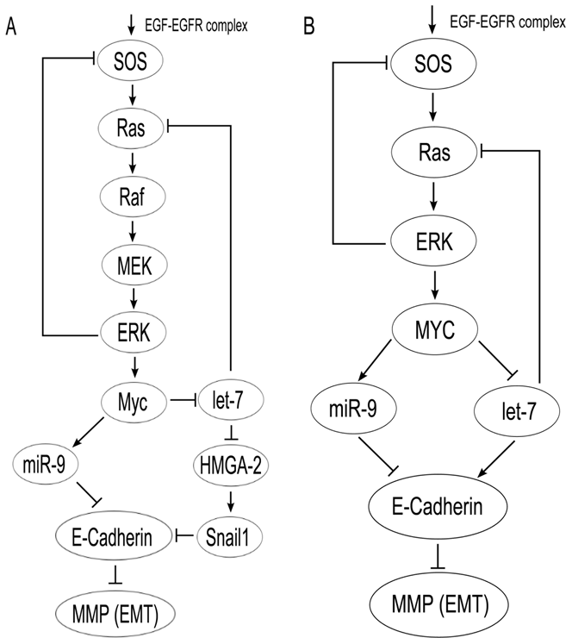

The signaling pathway that is used is based on deep investigation. It was found that let-7 was downregulated in NSCLC, which was similar in the case of breast cancer. An observation by Takamizawa et al. (2004) showed that there is an 80% reduction of let-7 in tumors when it was compared to uninvolved lung tissue. However in the same study only 7 out of the 16 cases demonstrated such reductions. Additionally a study conducted by Inamura et al. (2007) showed modest reductions in let-7 family members, which were close to 40%. Another study by Wang et al. (2011) showed that let-7 was repressed by MYC.

**FIGURE 1. A signaling pathway for lung cancer**

Also in another study by Johnson et al. (2005) it was observed that Ras was suppressed by let-7. Additionally another research displayed that HMGA-2 is repressed by let-7, which due to Thuault et al. 92008) it is the main cause for EMT which in the main time influences E-Cadherin. MMP in bronchial tumor cells is downregulated by the presence of E-Cadherin. In malignancies including lung cancer it has been noticed that E-Cadherin and MMP act as biomarkers. Moreover in a research conducted by Rao et al. (2005) they showed that adenoviral mediated gene transfer of MMP-9 could result in a reduction of lung cancer invasions, but also in the formation of metastases. In 140 cases there has been noticed an overexpression of miR-9 in lung tumors. MYC controls fundamental processes and it is also connected with cancer. Additionally researchers have found a connection between MYC and miRNAs, which is significant for cancer. What is more MYC can induce miR-9, which can inhibit tumor suppressor pathways and at the same time MYC can also inhibit let-7, which blocks oncogenic pathways. Wolfer and Ramaswamy (2011) used a signaling pathway that had let-7, EMT, E-Cadherin and miR-9 in order to find out how significant MYC is in breast cancer metastasis.

Lung cancer is the primary cause of cancer – related deaths in the world. Usually lung cancer is diagnosed at later stages and is proved to be fatal in the most of the cases. Researchers are trying to find a way to detect lung cancer in its earlier stages and therefore they are trying to identify and make biomarkers, which are going to be utilized for early detection. The paper proposes a mathematical model which includes miRNAs, let-7 and miR-9 into the EMT process. Furthermore based on experimental literature a signaling pathway was introduced which involves SOS, MMP, miR-9, miRNAs, MYC, Ras, ERK, E-Cadherin and let-7. Most recent studies have shown that there has been an increase in the levels of MMP-9 in NSCLC. A set of ordinary differential equations of SOS, Ras, ERK, miR-9, let-7, E-Cadherin, MYC, MMP mRNA and the model was used to record miR-9 overexpression and let-7 downexpression when EGFR and Ras mutations were set. These mutations decrease let-7 levels and increase miR-9 levels. Brown et al. (2004) did an EGFR signaling with negative feedback from ERK to SOS. Parts of the model they developed was taken to obtain the SOS, Ras and ERK equations. The concentrations of active SOS, inactive SOS and total SOS are denoted as S, Si and Stot. Then the activation rate of inactive SOS is defined by ms and the deactivation rate of active SOS is derived by ds. Then we replace ms with mSE and ds by dSEk, because we know that the EGFR complex initiates the activation of SOS and that ERK slows down the inactive SOS. Substituting all these we obtain Equation 1. Equations 2 and 3 are gotten byUsing Michaelis-Menten kinetics we get conversion between active and inactive Ras and between active and inactive ERK. For equation 4 we know that there is a proportionality between active ERK concentration and MYC production. For equation 5 the fourth order Hill function explains how miR-9 is activated by MYC. For equation 6 it is known that MYC inhibits the production of let-7 concentration. For equation 7 we know there is a proportionality between let-7 and E-Cadherin and that miR-9 inhibits E-Cadherin. Finally for equation 8 E-Cadherin degrades MMP while it is being produced at a steady rate.

Initially in the code a function was generated that would have all the ordinary differential equations of the different concentrations. The purpose of this was so that we can use ode15s an ordinary differential equation solver that is installed in Matlab to find the values of the different differential equations. The values for variables and for the parameters are going to be inputted so that the ode solver does not run the function with the same variable every time. Then a script was developed to solve for the ordinary differential equations and plot them as a function of time. The script starts with code, which is going to display graphs in the order they are displayed in the paper. Moreover plots of the different concentrations were performed for various input times such as from 0 to 1 min and from 0 to 105 min to show how they change as time progresses. Additionally plots of the concentrations were gotten for different parameter values in order to see the effect of increasing one parameter to the different concentrations. The parameters that were used are E=10E0, μR0 = 10 μR0 and δS0=10 δS0. 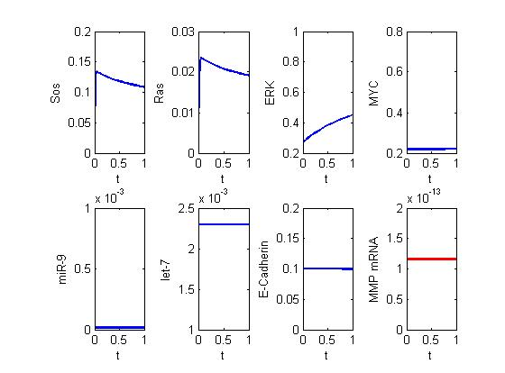These parameter values were used for times t = 0 to 1 min and t = 0 to 105 min. The change of the concentrations can be seen in the plots. Generally some concentrations whenever time and parameter values changed, such as Ras and some other concentrations only changed when time changed, such MYC. Furthermore there are graphs of miR-9, let-7 and MMP mRNA as E/E0, μR/μR0 and δS/δS0 change. The graphs suggest how the change of these input variables influence the

**FIGURE 2. Simulation results for a cancer cell with EGFR mutations, E=10E0**

concentration of these variables. Also there are comments in the code that explain what happens in each case, the definition of the variables, what is being shown, why the certain lines of code were used. The function that has all the differential equations needs to be in the same file with the project file. The user also needs to make sure that the file they want to run is in their current folder area in the main Matlab program page. The way the code works is the user starts the code from the top outside of the while loop. Then a menu shows up, which asks the user what he wants to see. Then the user chooses what he wants to see and a graph is outputted. The reason behind how that graph with specific features was outputted is explained in the code in the information about that graph. The user in the end can exit by pressing the “Exit” in the Menu and all the graphs and their variables in the workspace are going to be closed and deleted.